## From PDF

This creates a new plan from an external PDF document used as a background for your plan. To use this option, select **From PDF** at **step 1** as pictured below, and an **Open** window will appear for you to select the PDF from your computer. Select the PDF and click **Import**. You will see the PDF previewed in the window. If everything is correct, click **Next**.

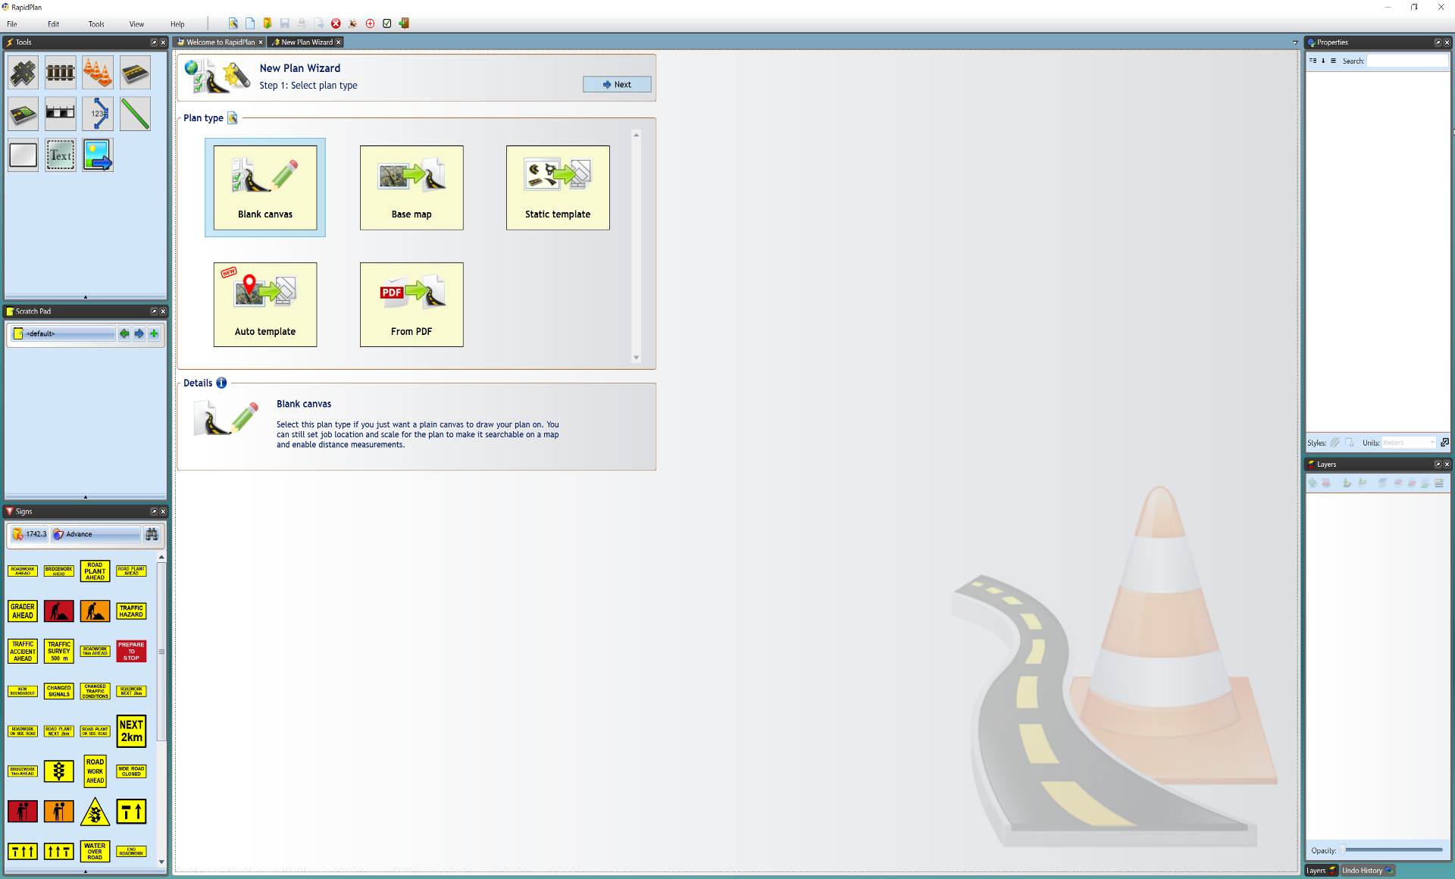

Select_Plan_Type

You will now be at the **step 2** window where you can enter your plan details. You can keep the default settings or enter your own details. Once these are entered, select **Create Plan** and the PDF will appear on your canvas area.